PROBLEM:1590

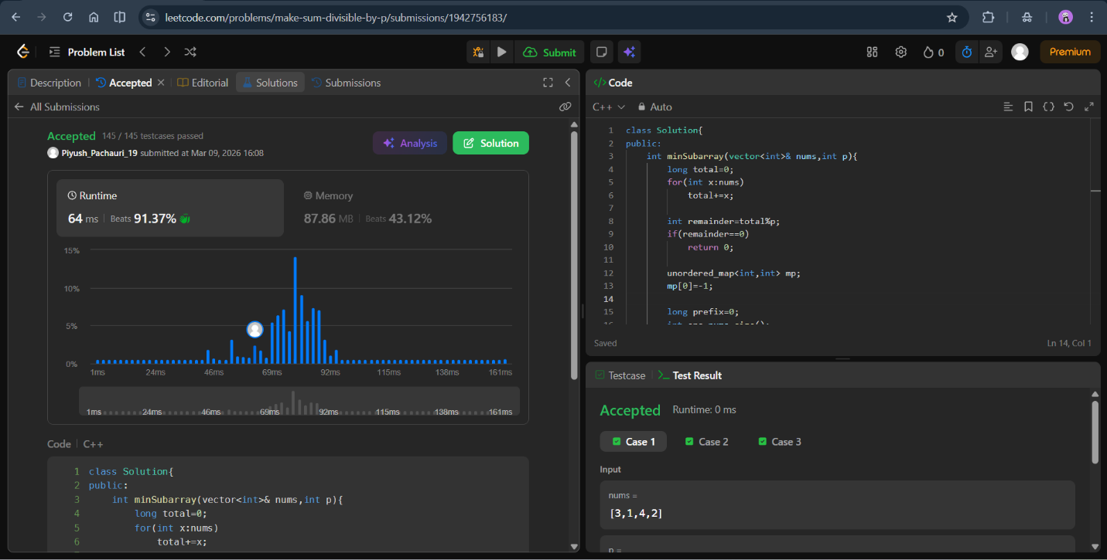
class Solution{
public:
int minSubarray(vector<int>& nums,int p){
long total=0;
for(int x:nums)
total+=x;

int remainder=total%p;
if(remainder==0)
return 0;

unordered_map<int,int> mp;
mp[0]=-1;

long prefix=0;
int ans=nums.size();

for(int i=0;i<nums.size();i++){
prefix=(prefix+nums[i])%p;
int target=(prefix-remainder+p)%p;

if(mp.count(target))
ans=min(ans,i-mp[target]);

mp[prefix]=i;
}

if(ans==nums.size())
return -1;

return ans;
}
};

PROBLEM:713

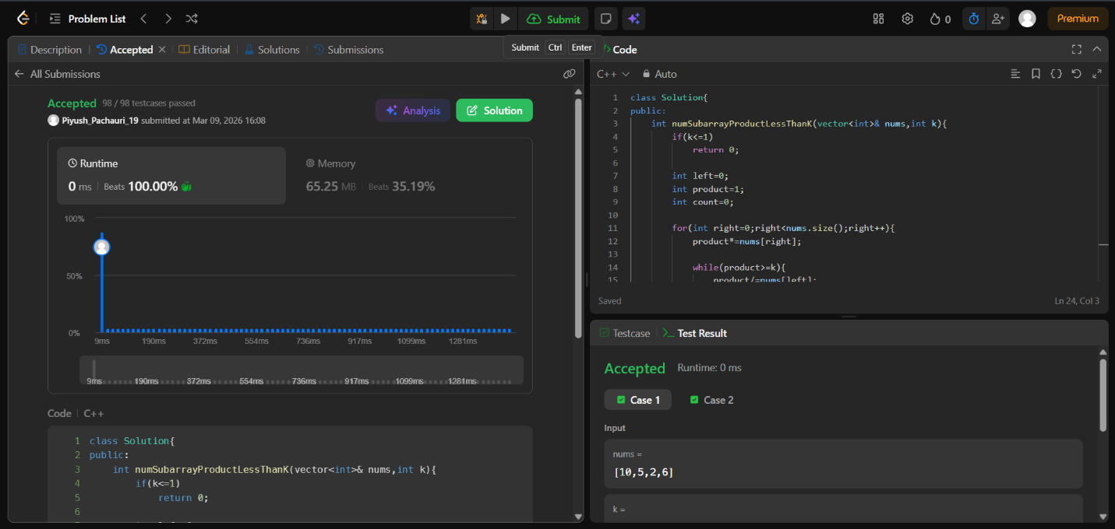
class Solution{
public:
int numSubarrayProductLessThanK(vector<int>& nums,int k){
if(k<=1)
return 0;

int left=0;
int product=1;
int count=0;

for(int right=0;right<nums.size();right++){
product*=nums[right];

while(product>=k){
product/=nums[left];
left++;
}

count+=right-left+1;
}

return count;
}
};

